|  |  |  |
| --- | --- | --- |
|  | **Window Object** | **Document Object** |
| Meaning: | The window object represents an open window in a browser.  If a document contain frames (<iframe> tags), the browser creates one window object for the HTML document, and one additional window object for each frame. | When an HTML document is loaded into a web browser, it becomes a document object.And the document object is the root node of the HTML document and also it is property of the window object. |
| Example | * location giving the current URL * history with methods back() and forward() giving the tab's mutable history * navigator describing the browser software | Each window object has a document object to be rendered. These objects get confused in part because HTML elements are added to the global object when assigned a unique id. E.g., in the HTML snippet  <body>  <p id="holyCow"> This is the first paragraph.</p>  </body>  let url = window.document.URL; |

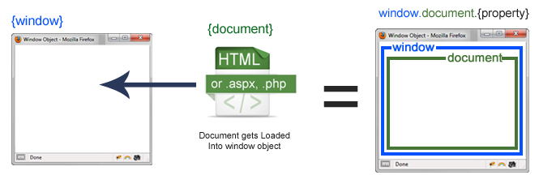

**Properties**



